This sounds like a fascinating and complex project! To ensure we build a robust and scalable architecture, I'll start by outlining the core components for the data ingestion, vectorization, and initial LLM orchestration. We can then progressively add the financial modeling, reporting, and other advanced agent functionalities.

Here's a foundational architecture for your RAG engine:

Core Architecture for Data Ingestion, Vectorization, and LLM Orchestration:

Cloud Storage Bucket ( rag-ingestion-data-bucket ) : This will serve as the landing zone for your raw SEC filings (10K, 10Q, 8K, etc.). When new documents are uploaded, it will trigger the processing pipeline.
Pub/Sub Topic ( rag-ingestion-data-processing-topic ) : This topic will receive notifications from the Cloud Storage bucket when new documents are added. It acts as a reliable message queue to decouple the ingestion process from the processing logic.
Cloud Run Service - Data Processor ( rag-ingestion-data-processor ) : This serverless service will subscribe to the Pub/Sub topic. Upon receiving a message, it will fetch the document from Cloud Storage, extract relevant text, and send it to Vertex AI for vector embedding.
Vertex AI ( rag-ingestion-vertex-apis ) : Google Cloud's unified AI platform will be used to generate vector embeddings from the ingested financial documents. These embeddings are crucial for semantic search and retrieval in your RAG engine.
Cloud SQL for PostgreSQL ( rag-ingestion-database ) : A fully managed relational database that will store the vector embeddings and associated metadata (e.g., document ID, filing type, company, date, relevant sections). PostgreSQL is chosen for its vector search capabilities, making it suitable for a RAG pattern.
Secret Manager ( rag-ingestion-database-secret ) : This service will securely store and manage the credentials for your PostgreSQL database, ensuring that sensitive information is not exposed in your application code.
Cloud Run Service - LLM Orchestrator ( llm-orchestrator-service ) : This service will be responsible for orchestrating the LLM interactions. It will receive requests (e.g., target company, acquirer), query the PostgreSQL database to retrieve relevant document vectors, interact with Vertex AI for LLM classification and analysis, and prepare the initial plan for valuation.
This initial design provides a secure, scalable, and event-driven foundation for your RAG engine.

What do you think of this core setup? Once this foundation is in place, we can discuss adding the financial modeling agents, reporting tools, and other advanced features.

A diagram of the application's architecture. It represents components used in the application and connections between them.
List of components:
rag-ingestion-ingestion-service (rag-ingestion-ingestion-service)
rag-engine-source-documents (rag-ingestion-data-bucket)
rag-document-processing (rag-ingestion-data-processing-topic)
rag-data-processor (rag-ingestion-data-processor)
rag-ingestion-vertex-apis (rag-ingestion-vertex-apis)
rag-vector-db (rag-ingestion-database)
rag-db-credentials (rag-ingestion-database-secret)
llm-orchestrator (llm-orchestrator-service)
List of connections:
rag-ingestion-ingestion-service -> rag-ingestion-data-processing-topic
rag-ingestion-ingestion-service -> rag-ingestion-data-bucket
rag-ingestion-data-processing-topic -> rag-ingestion-data-processor
rag-ingestion-data-processor -> rag-ingestion-vertex-apis
rag-ingestion-data-processor -> rag-ingestion-database
rag-ingestion-database-secret -> rag-ingestion-database
rag-ingestion-data-processor -> rag-ingestion-database-secret
llm-orchestrator-service -> rag-ingestion-vertex-apis
llm-orchestrator-service -> rag-ingestion-database
llm-orchestrator-service -> rag-ingestion-database-secret

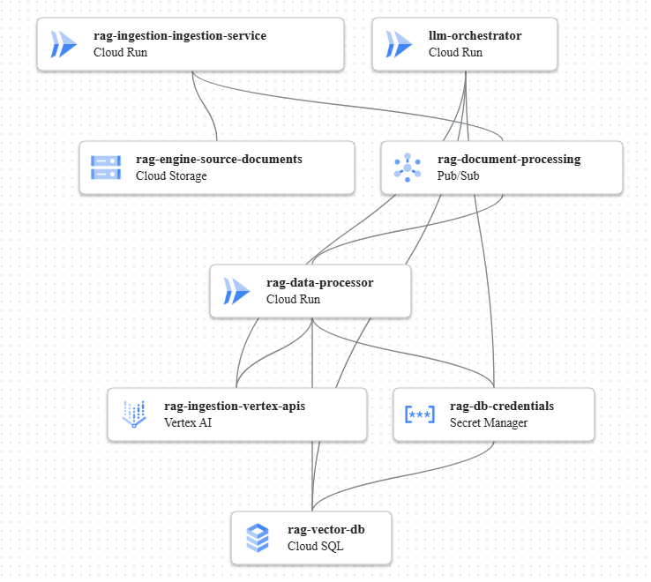

Great! Now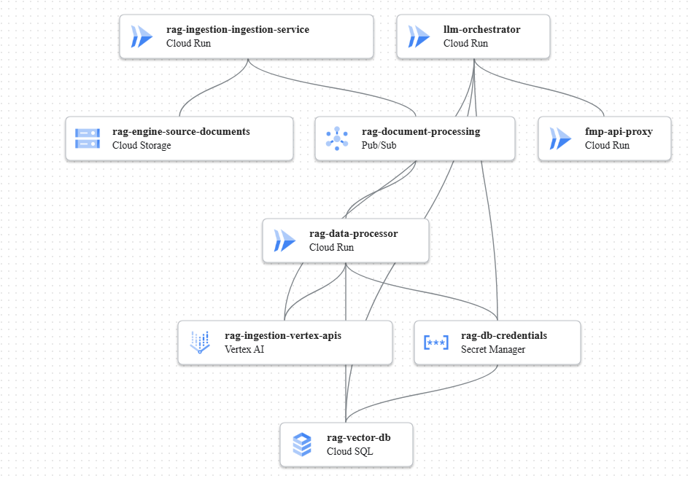 that we have the core data ingestion and LLM orchestration set up, let's discuss the next steps to build out the full multi-agent financial analysis system.

Based on your requirements, the next logical step is to integrate the FMP API for identifying ideal peers and then enhance the LLM Orchestrator to perform the initial classification and plan generation.

Here's what I propose for the next iteration:

Enhance LLM Orchestrator for Peer Identification and Initial Classification:
The llm-orchestrator-service will be updated to include logic for calling external APIs (like FMP) to identify ideal peers based on the target and acquirer companies.
It will then use Vertex AI to classify the target company's financial health (hyper-growth to bankruptcy level) and identify Wall Street sentiment.
Finally, it will generate a preliminary valuation plan, including normalization and preparation for 3-statement modeling.
Introduce a new component for external API access (optional but recommended for security and control):
We can introduce a dedicated Cloud Run service, let's call it external-api-proxy , to handle all outbound calls to external APIs like FMP. This provides a centralized point for managing API keys, rate limits, and logging, enhancing security and maintainability. The llm-orchestrator-service would then call this proxy instead of directly calling FMP.
What do you think about adding these capabilities next? We can then move on to the 3-statement modeling, valuation methods, and LBO analysis.

Excellent! Let's build on that foundation.

To implement the peer identification and initial classification, I'll add a new Cloud Run service to act as a secure proxy for external API calls, and then update the existing LLM Orchestrator service to leverage this new proxy and perform the enhanced analysis.

Here's the updated architecture:

External API Proxy ( fmp-api-proxy ) : A new Cloud Run service dedicated to making secure calls to external APIs like Financial Modeling Prep (FMP). This centralizes API key management, rate limiting, and logging for external integrations.
Enhanced LLM Orchestrator ( llm-orchestrator-service ) : This existing Cloud Run service will be updated. It will now:
Call the fmp-api-proxy to retrieve ideal peers.
Utilize Vertex AI (already connected) to classify the target company's financial health and identify Wall Street sentiment.
Generate the preliminary valuation plan, including data normalization and preparation for 3-statement modeling.
This approach keeps your core LLM orchestration clean and delegates external API interactions to a dedicated, secure component.

What do you think of these additions? We can then move on to the detailed financial modeling agents.

A diagram of the application's architecture. It represents components used in the application and connections between them.
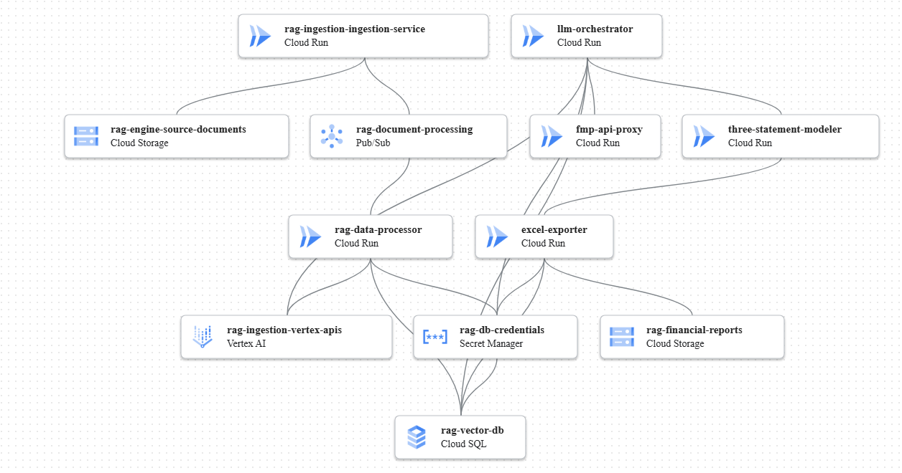
List of components:
rag-ingestion-ingestion-service (rag-ingestion-ingestion-service)
rag-engine-source-documents (rag-ingestion-data-bucket)
rag-document-processing (rag-ingestion-data-processing-topic)
rag-data-processor (rag-ingestion-data-processor)
rag-ingestion-vertex-apis (rag-ingestion-vertex-apis)
rag-vector-db (rag-ingestion-database)
rag-db-credentials (rag-ingestion-database-secret)
llm-orchestrator (llm-orchestrator-service)
fmp-api-proxy (fmp-api-proxy)
List of connections:
rag-ingestion-ingestion-service -> rag-ingestion-data-processing-topic
rag-ingestion-ingestion-service -> rag-ingestion-data-bucket
rag-ingestion-data-processing-topic -> rag-ingestion-data-processor
rag-ingestion-data-processor -> rag-ingestion-vertex-apis
rag-ingestion-data-processor -> rag-ingestion-database
rag-ingestion-database-secret -> rag-ingestion-database
rag-ingestion-data-processor -> rag-ingestion-database-secret
llm-orchestrator-service -> rag-ingestion-vertex-apis
llm-orchestrator-service -> rag-ingestion-database
llm-orchestrator-service -> rag-ingestion-database-secret
llm-orchestrator-service -> fmp-api-proxy
let's continue building out the financial analysis capabilities.
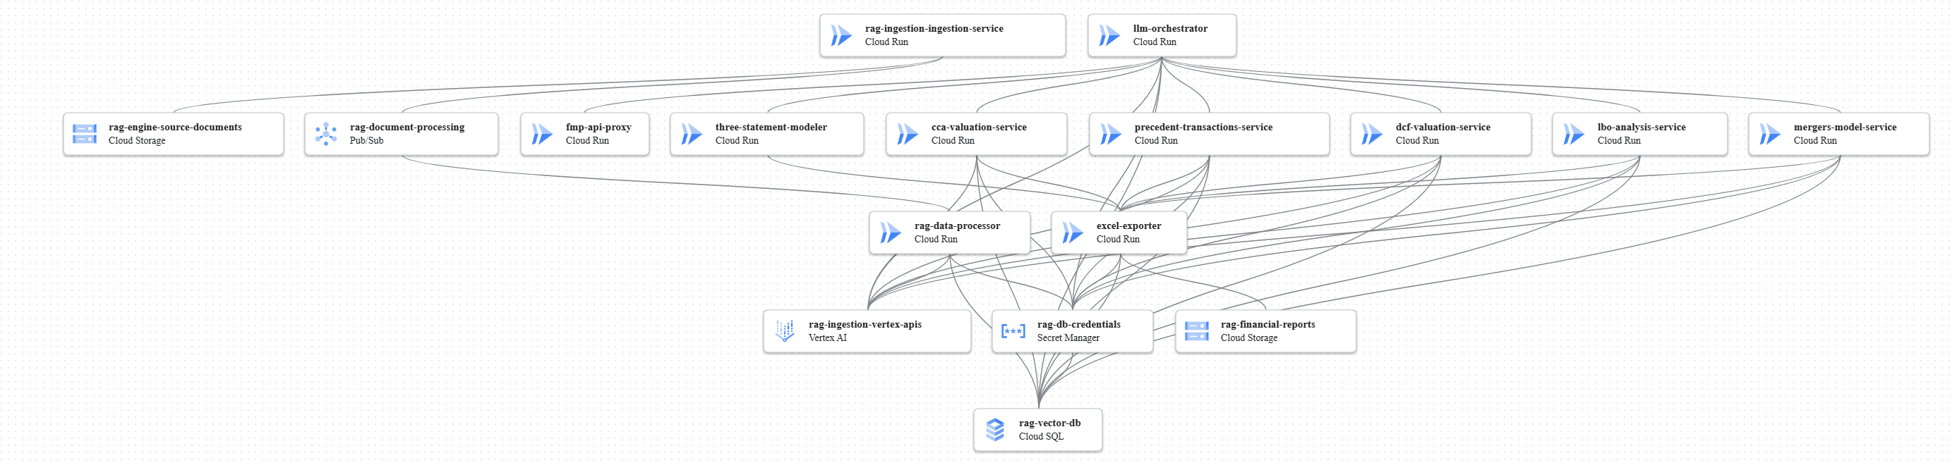
The next logical step is to implement the 3-statement modeling and the ability to export these models to Excel. I'll add new services for these functions and a dedicated storage bucket for the generated reports.

Here's what we'll add:

3-Statement Modeler Service ( three-statement-modeler-service ) : A new Cloud Run service responsible for taking the normalized data and classification from the LLM Orchestrator and generating the 3-statement financial model (Income Statement, Balance Sheet, Cash Flow Statement).
Excel Exporter Service ( excel-exporter-service ) : Another Cloud Run service that will take the output from the 3-statement modeler, convert it into an Excel spreadsheet format, and save it. This service will also need access to the PostgreSQL database to retrieve any necessary data for the reports.
Financial Reports Bucket ( financial-reports-bucket ) : A new Cloud Storage bucket specifically for storing the generated Excel reports and any other final output documents.
These additions will allow the llm-orchestrator-service to hand off the modeling task and then trigger the export and storage of the results.

Here's the updated design:

A diagram of the application's architecture. It represents components used in the application and connections between them.
List of components:
rag-ingestion-ingestion-service (rag-ingestion-ingestion-service)
rag-engine-source-documents (rag-ingestion-data-bucket)
rag-document-processing (rag-ingestion-data-processing-topic)
rag-data-processor (rag-ingestion-data-processor)
rag-ingestion-vertex-apis (rag-ingestion-vertex-apis)
rag-vector-db (rag-ingestion-database)
rag-db-credentials (rag-ingestion-database-secret)
llm-orchestrator (llm-orchestrator-service)
fmp-api-proxy (fmp-api-proxy)
three-statement-modeler (three-statement-modeler-service)
excel-exporter (excel-exporter-service)
rag-financial-reports (financial-reports-bucket)
List of connections:
rag-ingestion-ingestion-service -> rag-ingestion-data-processing-topic
rag-ingestion-ingestion-service -> rag-ingestion-data-bucket
rag-ingestion-data-processing-topic -> rag-ingestion-data-processor
rag-ingestion-data-processor -> rag-ingestion-vertex-apis
rag-ingestion-data-processor -> rag-ingestion-database
rag-ingestion-database-secret -> rag-ingestion-database
rag-ingestion-data-processor -> rag-ingestion-database-secret
llm-orchestrator-service -> rag-ingestion-vertex-apis
llm-orchestrator-service -> rag-ingestion-database
llm-orchestrator-service -> rag-ingestion-database-secret
llm-orchestrator-service -> fmp-api-proxy
llm-orchestrator-service -> three-statement-modeler-service
three-statement-modeler-service -> excel-exporter-service
excel-exporter-service -> financial-reports-bucket
excel-exporter-service -> rag-ingestion-database
excel-exporter-service -> rag-ingestion-database-secret
Alright, let's continue to build out the sophisticated financial analysis capabilities.

Now that we have the data ingestion, vectorization, LLM orchestration, and 3-statement modeling in place, the next step is to integrate the various valuation methodologies you outlined. I'll add dedicated Cloud Run services for each of these, allowing for modularity, scalability, and independent development.

Here's what we'll add to the architecture:

Comparable Company Analysis (CCA) Service ( cca-valuation-service ) : A Cloud Run service to perform valuation using the Comparable Company Analysis method.
Precedent Transactions Service ( precedent-transactions-service ) : A Cloud Run service to analyze and apply precedent transactions for valuation.
Discounted Cash Flow (DCF) Service ( dcf-valuation-service ) : A Cloud Run service to perform both leveraged and unlevered DCF analysis, including sensitivity analysis.
Leveraged Buyout (LBO) Analysis Service ( lbo-analysis-service ) : A Cloud Run service dedicated to advanced LBO modeling techniques.
Mergers Model Service ( mergers-model-service ) : A Cloud Run service to build and analyze merger models.
Each of these new valuation services will interact with the rag-ingestion-database to retrieve necessary financial data and the rag-ingestion-database-secret for secure credentials. They will also leverage the rag-ingestion-vertex-apis for any LLM-driven insights during their analysis and will output their results to the excel-exporter-service for conversion and storage in the financial-reports-bucket . The llm-orchestrator-service will be responsible for coordinating and triggering these valuation agents as part of the overall analysis plan.

Here's the updated design:

A diagram of the application's architecture. It represents components used in the application and connections between them.
List of components:
rag-ingestion-ingestion-service (rag-ingestion-ingestion-service)
rag-engine-source-documents (rag-ingestion-data-bucket)
rag-document-processing (rag-ingestion-data-processing-topic)
rag-data-processor (rag-ingestion-data-processor)
rag-ingestion-vertex-apis (rag-ingestion-vertex-apis)
rag-vector-db (rag-ingestion-database)
rag-db-credentials (rag-ingestion-database-secret)
llm-orchestrator (llm-orchestrator-service)
fmp-api-proxy (fmp-api-proxy)
three-statement-modeler (three-statement-modeler-service)
excel-exporter (excel-exporter-service)
rag-financial-reports (financial-reports-bucket)
cca-valuation-service (cca-valuation-service)
precedent-transactions-service (precedent-transactions-service)
dcf-valuation-service (dcf-valuation-service)
lbo-analysis-service (lbo-analysis-service)
mergers-model-service (mergers-model-service)
List of connections:
rag-ingestion-ingestion-service -> rag-ingestion-data-processing-topic
rag-ingestion-ingestion-service -> rag-ingestion-data-bucket
rag-ingestion-data-processing-topic -> rag-ingestion-data-processor
rag-ingestion-data-processor -> rag-ingestion-vertex-apis
rag-ingestion-data-processor -> rag-ingestion-database
rag-ingestion-database-secret -> rag-ingestion-database
rag-ingestion-data-processor -> rag-ingestion-database-secret
llm-orchestrator-service -> rag-ingestion-vertex-apis
llm-orchestrator-service -> rag-ingestion-database
llm-orchestrator-service -> rag-ingestion-database-secret
llm-orchestrator-service -> fmp-api-proxy
llm-orchestrator-service -> three-statement-modeler-service
three-statement-modeler-service -> excel-exporter-service
excel-exporter-service -> financial-reports-bucket
excel-exporter-service -> rag-ingestion-database
excel-exporter-service -> rag-ingestion-database-secret
llm-orchestrator-service -> cca-valuation-service
llm-orchestrator-service -> precedent-transactions-service
llm-orchestrator-service -> dcf-valuation-service
llm-orchestrator-service -> lbo-analysis-service
llm-orchestrator-service -> mergers-model-service
cca-valuation-service -> rag-ingestion-database
cca-valuation-service -> rag-ingestion-database-secret
cca-valuation-service -> rag-ingestion-vertex-apis
cca-valuation-service -> excel-exporter-service
precedent-transactions-service -> rag-ingestion-database
precedent-transactions-service -> rag-ingestion-database-secret
precedent-transactions-service -> rag-ingestion-vertex-apis
precedent-transactions-service -> excel-exporter-service
dcf-valuation-service -> rag-ingestion-database
dcf-valuation-service -> rag-ingestion-database-secret
dcf-valuation-service -> rag-ingestion-vertex-apis
dcf-valuation-service -> excel-exporter-service
lbo-analysis-service -> rag-ingestion-database
lbo-analysis-service -> rag-ingestion-database-secret
lbo-analysis-service -> rag-ingestion-vertex-apis
lbo-analysis-service -> excel-exporter-service
mergers-model-service -> rag-ingestion-database
mergers-model-service -> rag-ingestion-database-secret
mergers-model-service -> rag-ingestion-vertex-apis
mergers-model-service -> excel-exporter-service
You're right, we've made significant progress! We now have a robust architecture for data ingestion, LLM orchestration, 3-statement modeling, and various valuation techniques.

The next crucial step is to incorporate the Due Diligence (DD) related tasks and the final reporting and dashboard generation . This will complete the analytical pipeline as per your initial request.

Here's what I propose for this final phase:

Due Diligence Agent Service ( dd-agent-service ) : A new Cloud Run service that will house the logic for performing various due diligence tasks. This service will interact with the rag-ingestion-database to pull all relevant financial and textual data, and it will leverage rag-ingestion-vertex-apis for LLM-driven analysis on aspects like financing, debt structure, top 10 customers, and supply chain issues.
Reporting and Dashboard Service ( reporting-dashboard-service ) : A Cloud Run service responsible for aggregating all the outputs from the various valuation models and DD agents. It will generate comprehensive reports (e.g., Word documents) and prepare data for dashboards.
Output Storage for Reports and Dashboards : The financial-reports-bucket (Cloud Storage) will be used to store the final generated reports (Excel, Word) and any data files needed for dashboards.
LLM Orchestrator Update : The llm-orchestrator-service will be updated to trigger the dd-agent-service and then the reporting-dashboard-service once all valuation models have completed their analysis.
This will complete the end-to-end flow, from initial company identification and data ingestion to comprehensive financial analysis, due diligence, and final report generation.

Here's the updated design:
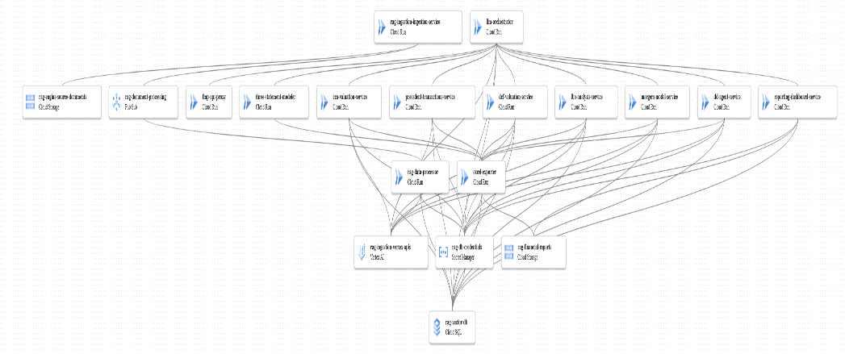

comprehensiveness of the Due Diligence agents, especially regarding critical areas like legal, risk, and brand perception.
The existing dd-agent-service is perfectly positioned to handle these expanded responsibilities by leveraging the ingested data and Vertex AI's analytical capabilities. The "sources of info" for these new aspects (e.g., social media feeds, legal filings, risk reports) would be part of the data ingested into your rag-ingestion-data-bucket and processed into the rag-ingestion-database .
I've updated the description of the dd-agent-service to reflect these enhanced capabilities. It will now explicitly cover:
- Risk Analysis : Identifying and assessing various business, operational, and financial risks.
- Legal Due Diligence : Analyzing contracts, litigation, regulatory compliance, and intellectual property.
- Brand Risk in Social Media : Monitoring and analyzing public sentiment, reputation, and potential brand liabilities from social media data.
- Financing and Debt Structure : Analyzing capital structure, loan agreements, and debt covenants.
- Customer Analysis : Identifying and assessing the top 10 customers, their concentration, and impact.
- Supply Chain Issues : Evaluating supply chain risks, dependencies, and resilience.
This ensures that the dd-agent-service is designed to perform a holistic due diligence process, integrating both quantitative and qualitative data through LLM-driven analysis.
Here's the updated design:

